

**Table of Contents**

* Title of the Project and Introduction…………………………2
* Goals and Objectives…………………………………………………4
* Software & Language Used…………………………………….…5
* Purpose…………………………………………………………………….6
* Website Screenshots/Codes……………………………………..9
* SDLC Model………………………………………………………………10
* Conclusion………………………………………………………………..11
* Bibliography……………………………………………………………..12

**Title & Logo of the Project:**

**Local Nest - A Digital Hub for MCA Students**

In the age of digital connectivity, educational institutions are continuously exploring avenues to enhance collaboration, streamline communication, and provide valuable resources to their student body. Introducing "Local Nest," a comprehensive online platform designed specifically for the Master of Computer Applications (MCA) students at our esteemed university.

**Introduction:**

The Title I have selected for this project is **Local Nest**.

Your can visit the website (link: www.localnest.com)

**Title & Introduction**

**Empowering Connections:** The core of Local Nest lies in fostering connections within the MCA community. Through a user-friendly registration and login system, students and faculty alike can join a vibrant digital space where they can engage in real-time communication, share valuable insights, and exchange essential documents, thus enriching their academic journey.

**Staying Updated:** Keeping pace with the dynamic nature of academia, Local Nest offers a dedicated section for updates and syllabus tracking. Here, MCA students can seamlessly access the latest announcements from the university administration, as well as review the curriculum and syllabi pertinent to their academic pursuits.

**Immersive Exploration:** Beyond the confines of traditional learning, Local Nest opens the doors to a virtual tour experience. Through immersive 360-degree panoramas, users can embark on a digital journey through our university campus, exploring every department and facility with unprecedented ease and convenience.

**Charting Futures:** As MCA students navigate their academic journey, Local Nest provides a unique feature - "Roadmap." Here, students can chart their post-MCA trajectory, exploring various career paths, higher education opportunities, and professional development avenues. Whether it's pursuing advanced studies or delving into the realm of employment, Local Nest equips students with the resources they need to carve out their desired futures.

**Goals and Objectives of Local Nest:**

**Goal 1: Enhancing Collaboration and Communication** *Objective:*

* To facilitate seamless communication and collaboration among MCA students and faculty members.
* To provide a platform where students can engage in discussions, share knowledge, and seek assistance from peers and educators.

**Goal 2: Providing Access to Timely Updates and Resources** *Objective:*

* To ensure that MCA students stay informed about the latest university updates, including announcements, events, and academic changes.
* To offer a centralized repository of syllabi, study materials, and resources relevant to the MCA curriculum, aiding students in their academic endeavours.

**Goals and Objectives**

**Goal 3: Offering Immersive Exploration** *Objective:*

* To enable MCA students to virtually explore the university campus and its facilities through immersive 360-degree tours.
* To provide a platform for prospective students to familiarize themselves with the university environment before joining.

**Goal 4: Empowering Career Planning and Development** *Objective:*

* To assist MCA students in charting their post-graduation career paths by providing information about various job opportunities, higher education options, and professional development resources.
* To empower students to make informed decisions about their future endeavours through personalized career roadmap tools and guidance.

**Goal 5: Promoting Engagement and Participation** *Objective:*

* To foster a sense of belonging and community among MCA students by encouraging active participation in discussions, events, and virtual tours.
* To continuously gather feedback from users and iterate on the platform's features to better meet the evolving needs of the MCA community.

1. **Visual Studio:**
   * Visual Studio serves as the primary Integrated Development Environment (IDE) for developing and managing the Local Nest website. Its robust features and intuitive interface facilitate efficient coding, debugging, and project management.
2. **Apache Server:**
   * Apache Server is employed as the backend server for hosting and managing the database of Local Nest. It provides a reliable and scalable platform for storing and retrieving user data, ensuring seamless functionality and performance of the website.
3. **JavaScript:**
   * JavaScript is utilized extensively to enhance the interactivity and functionality of Local Nest. It powers dynamic elements such as real-time chat features, interactive forms, and asynchronous data loading, enriching the user experience and facilitating seamless communication between students and teachers.

**Software & Language Used**

4.**HTML & CSS:**

* + HTML (Hypertext Markup Language) and CSS (Cascading Style Sheets) are the foundation of Local Nest's frontend development. HTML structures the content of web pages, while CSS is used to style and layout these elements, ensuring a visually appealing and user-friendly interface.

5.**JSON (JavaScript Object Notation):**

* + JSON is employed for data interchange between the frontend and backend components of Local Nest. It serves as a lightweight and readable format for transmitting structured data, facilitating seamless communication and data manipulation within the application.

6.**AJAX (Asynchronous JavaScript and XML):**

* + AJAX is leveraged to enable asynchronous data exchange between the browser and server, enhancing the responsiveness and efficiency of Local Nest. It allows for dynamic updating of content without requiring a full page reload, resulting in a smoother and more seamless user experience.

7.**PHP:**

* + PHP (Hypertext Preprocessor) is utilized for server-side scripting in Local Nest, enabling dynamic content generation and database interaction. It powers backend functionalities such as user authentication, data processing, and server-side rendering, ensuring the smooth operation of the website's features.

8.**MySQL:**

* + MySQL is employed as the relational database management system (RDBMS) for storing and managing user data, chat messages, and other relevant information within Local Nest. Its robust features and scalability make it well-suited for handling the diverse data requirements of the application.

**Purpose of Local Nest Project:**

The primary purpose of the Local Nest project is to create a comprehensive digital platform tailored specifically for the Master of Computer Applications (MCA) students within our university community. This purpose is multifaceted and encompasses several key objectives:

1. **Enhancing Connectivity:** Local Nest aims to foster a sense of community and collaboration among MCA students and faculty members by providing a centralized platform for communication and interaction. Through features such as real-time chat capabilities and document sharing, the project facilitates seamless connectivity, enabling students to engage with each other and with educators more effectively.
2. **Facilitating Academic Support:** Another core purpose of Local Nest is to serve as a hub for academic resources and support. By offering access to updates, syllabi, and study materials, the platform empowers MCA students to stay informed about curriculum changes, academic events, and relevant announcements from the university administration. This facilitates their academic journey and helps them stay on track with their studies.

**Purpose**

**3.Enabling Virtual Exploration:** Local Nest goes beyond conventional academic support by providing an immersive virtual tour experience of the university campus. Through 360-degree photos and interactive maps, students can explore different departments and facilities virtually, gaining insight into the university's physical layout and resources. This feature serves to familiarize both current and prospective students with the campus environment, enhancing their overall university experience.

**4.Supporting Career Development:** The project also aims to support MCA students in their post-graduation career planning and development. Through the "Roadmap" feature, students can explore various career paths, higher education opportunities, and professional development avenues available to them after completing their MCA studies. By providing access to relevant resources and guidance, Local Nest empowers students to make informed decisions about their future endeavours.

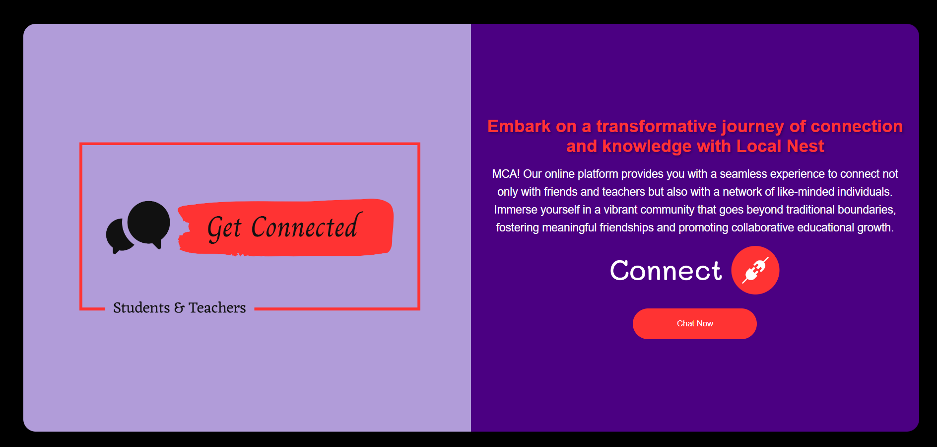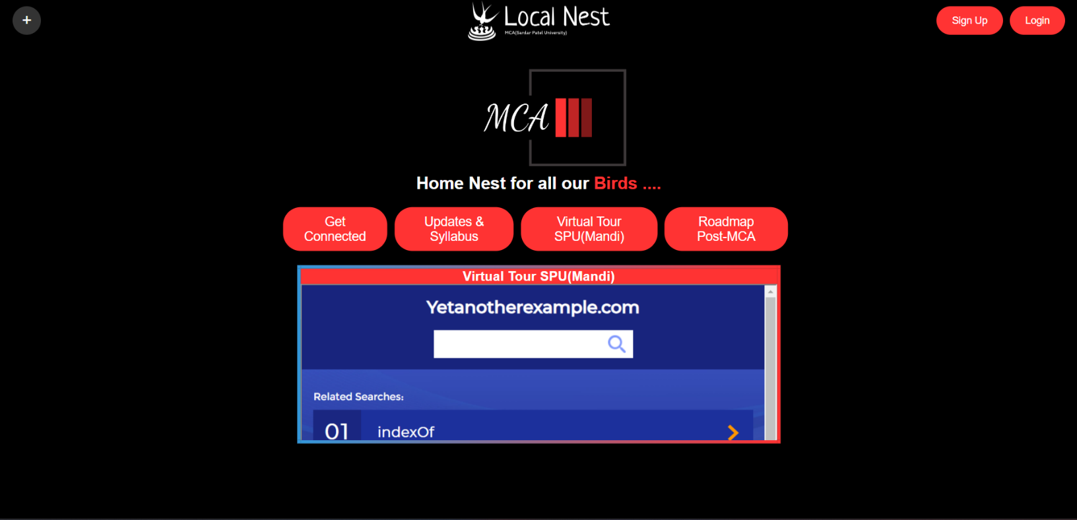

**Home Page**

**Website Screenshots/Codes**

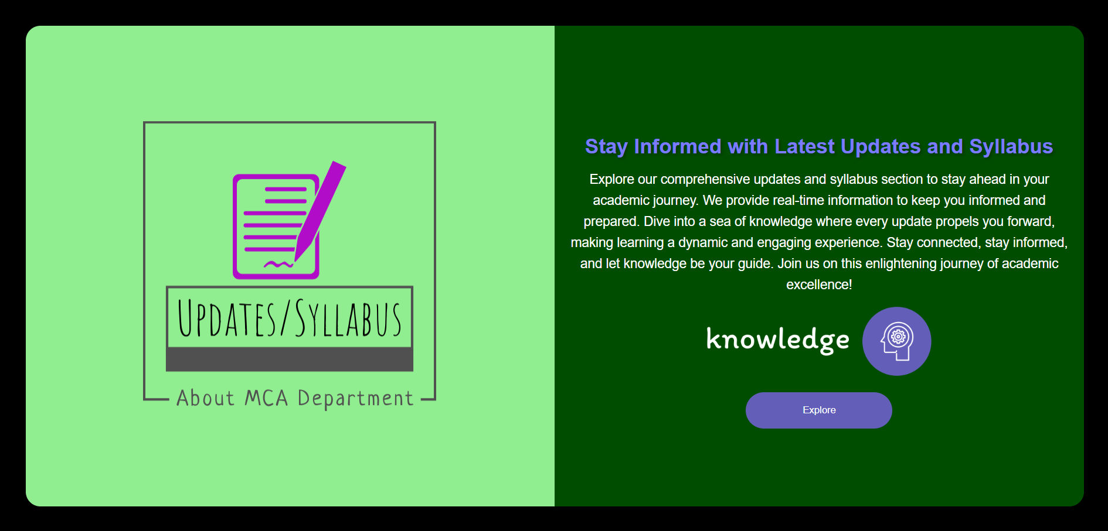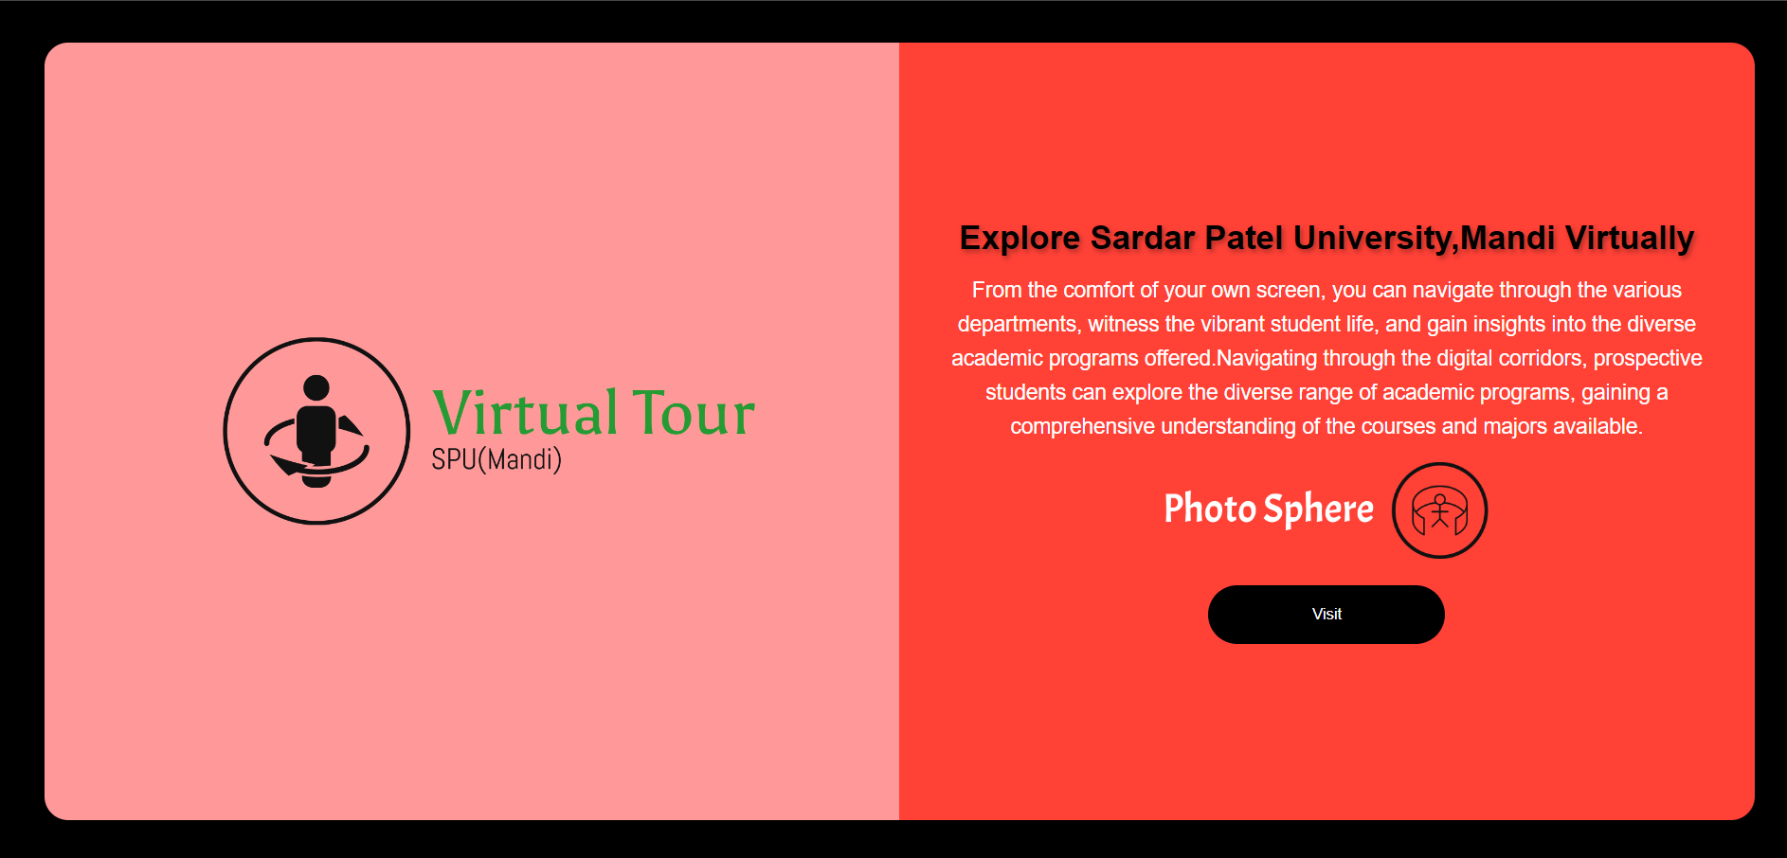

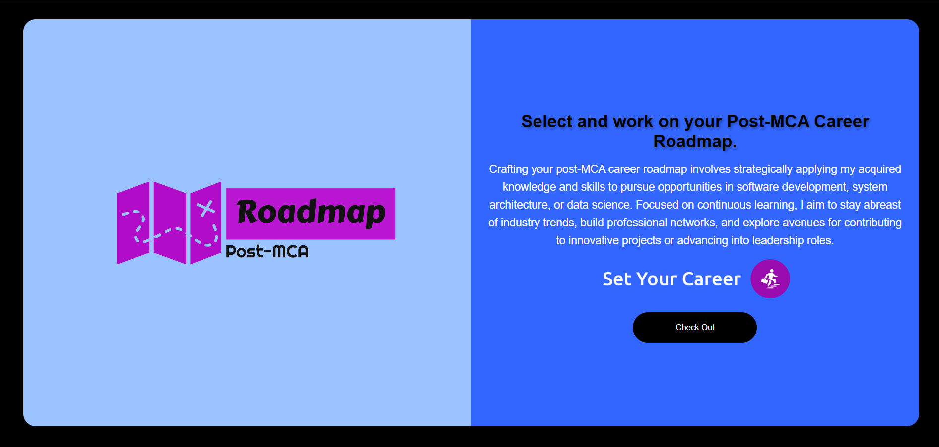

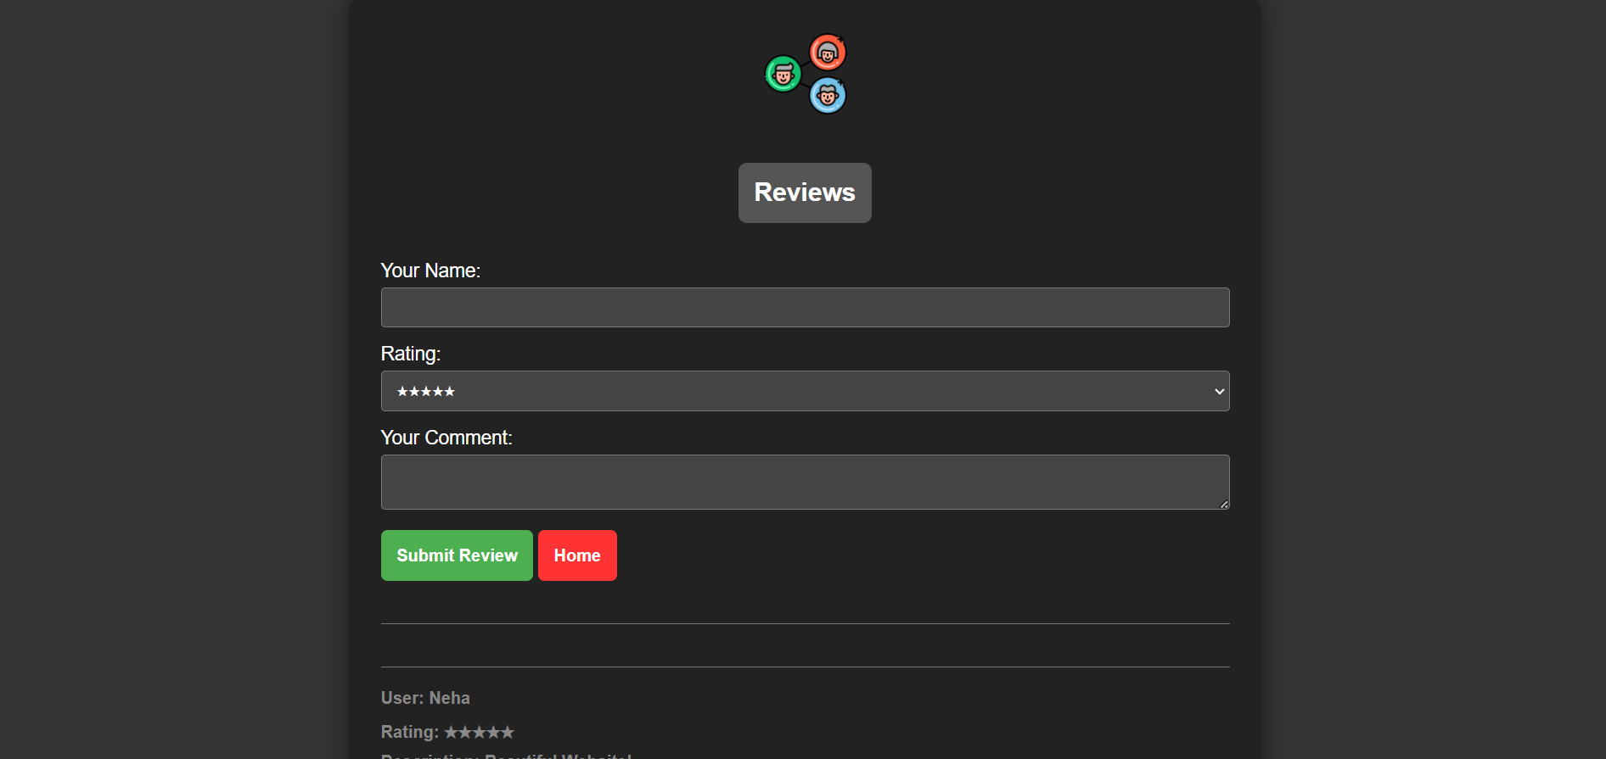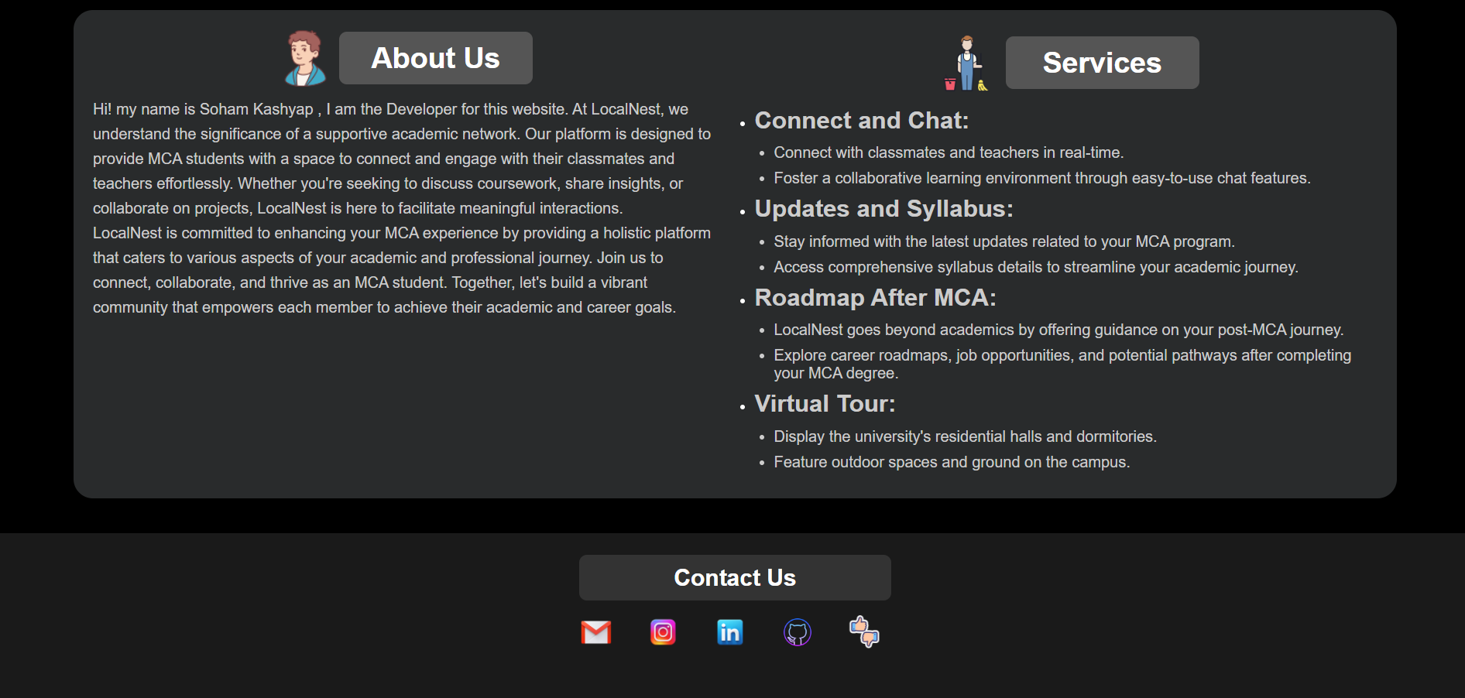

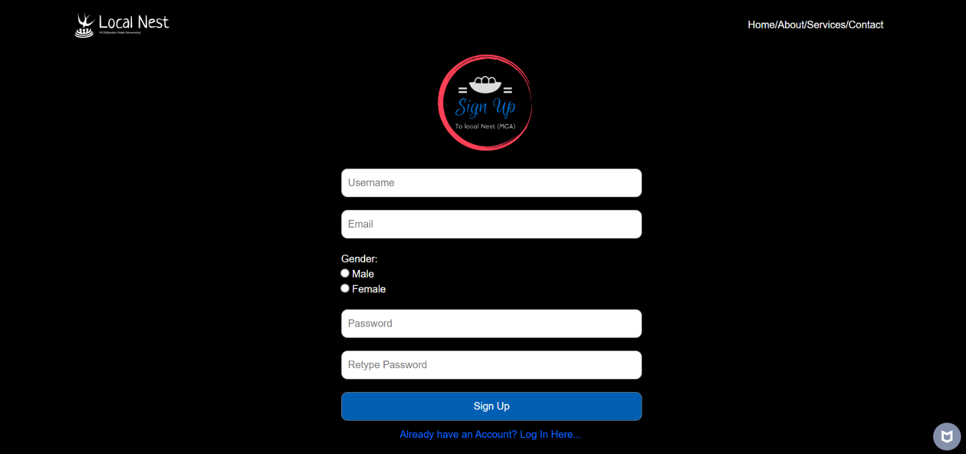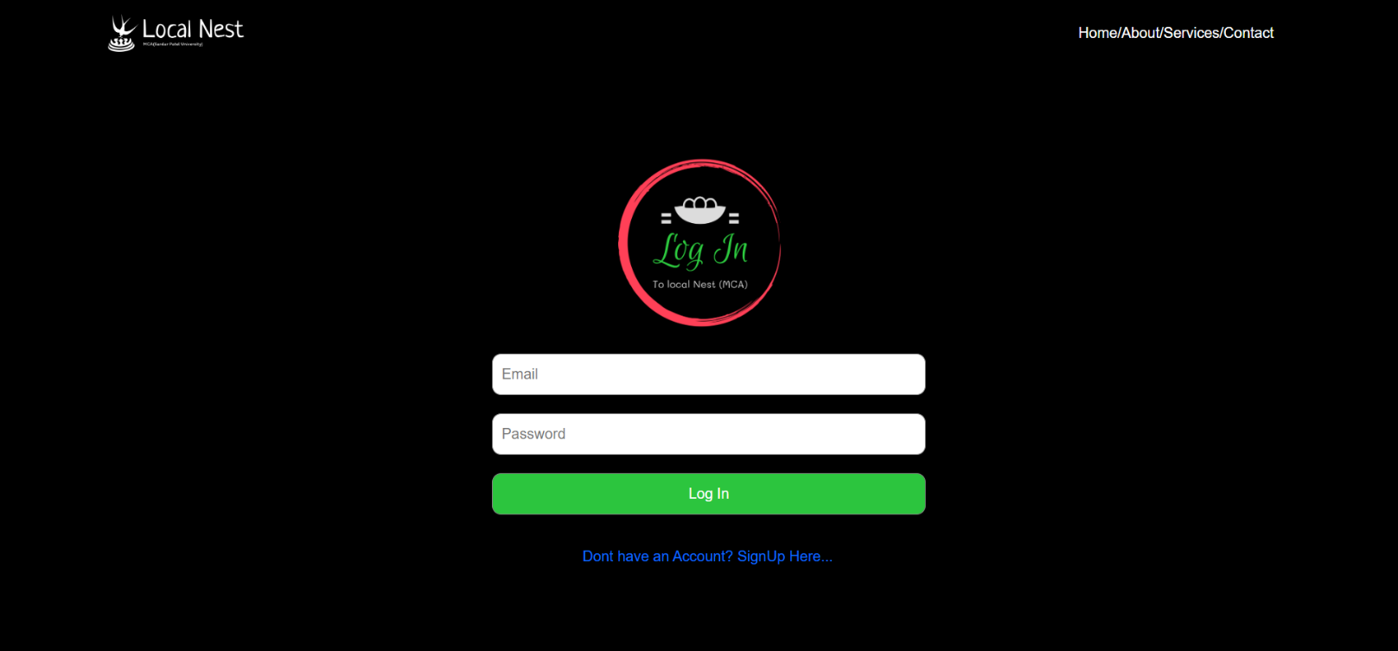

**1.Get Connected**

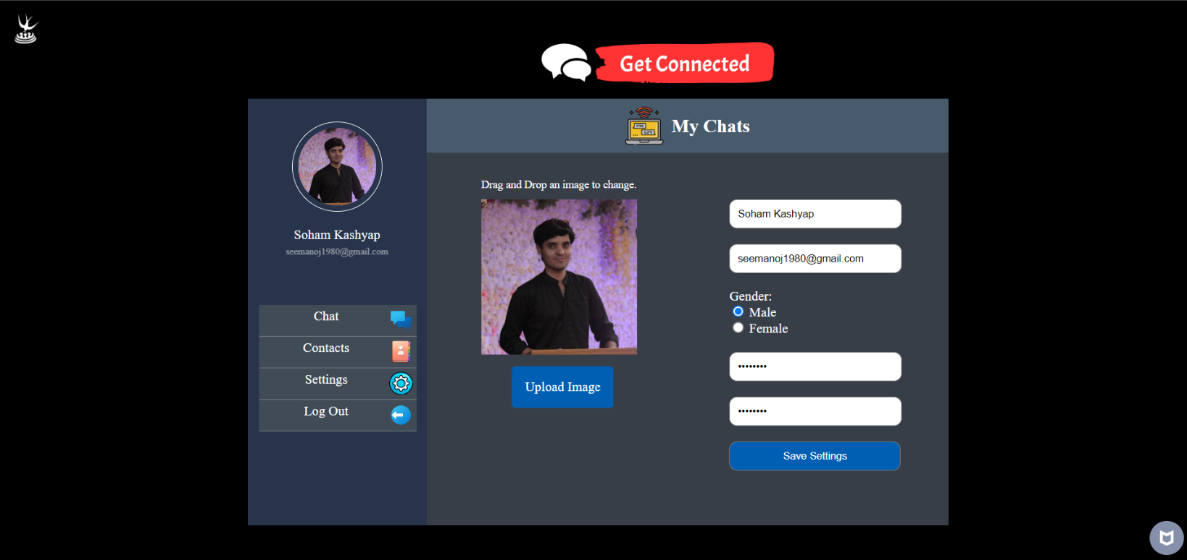

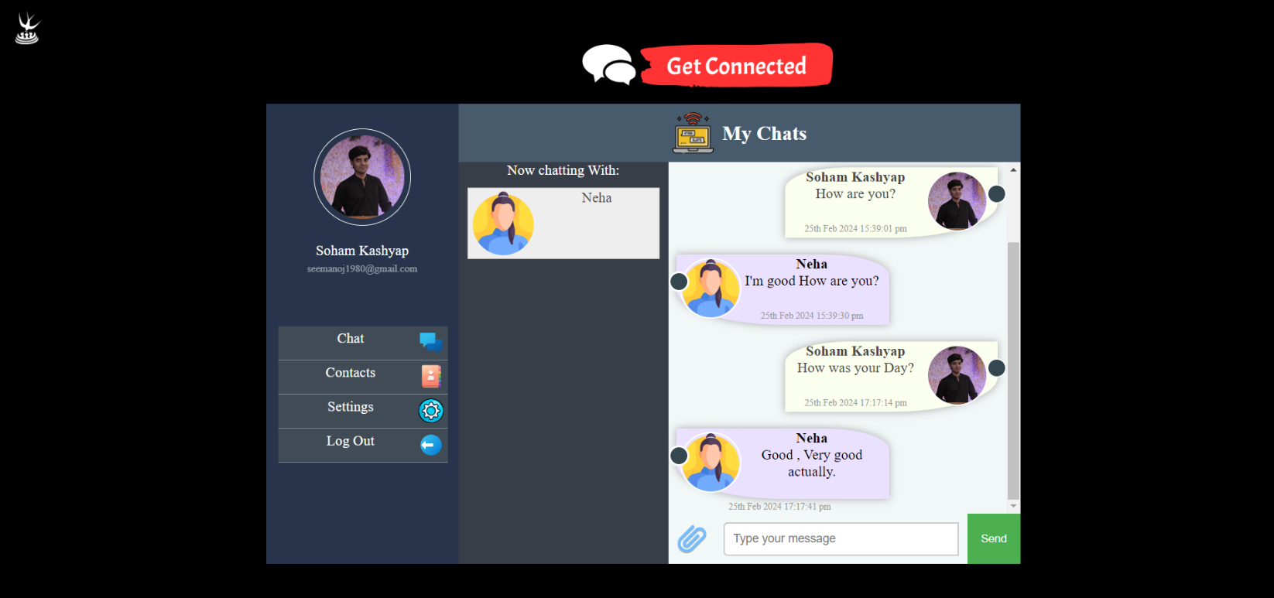

**SDLC Model**

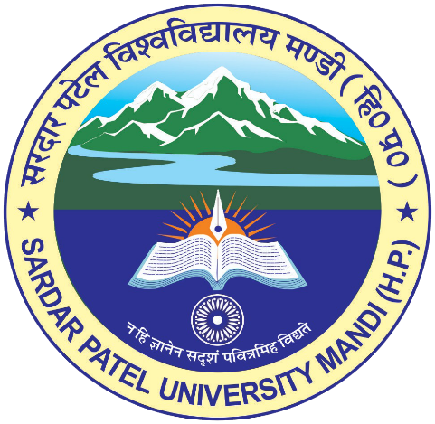

**Presented by:**

**Name**: -Soham Kashyap

**Roll Number**: -MCA-38

**Class**: -MCA 4th Semester

**Project Guide:**

Mrs. Ruchi Thakur

**SARDAR PATEL UNIVERSITY MANDI**

Department of Computer Application

**Project Report**